Create Assignments
Hillary L.
Last Updated: July 02, 2015 13:47
This topic covers how to create a new assignment.
- Select the class for which you want to create the assignment. If necessary, select Gradebook from the left sidebar to access your class Gradebook.
- From your Gradebook, select the New Assignment button at the top left.
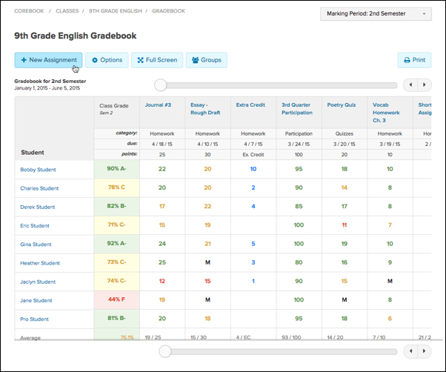

- Enter the following assignment details:
  - Assignment Name: Enter the name that will show up in your Gradebook, on printed reports and in student/parent accounts for this assignment.
  - Points Possible: Enter the total amount of points a student can earn on the assignment.
  - Due Date: Enter the date that the assignment is due.
  - Category: Select the assignment category in which your new assignment belongs.
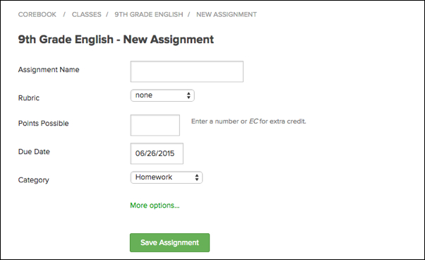
- Select More options... to reveal some more advanced assignment settings, including:
  - Standard Set: If your school is using a specific set of standards, you can select the appropriate set.
  - Standards: Click Tag Standards, and select the checkbox of the appropriate standards that you would like to be tagged to your new assignment.
  - Description: If you would like to add a description and/or provide additional instructions for students and parents to see online, you can add that information here.
  - Attach: If you need to attach a file to your new assignment, you can attach up to 50 files per assignment.
  - Copy to Classes: If you would like to copy this assignment to multiple classes, you can select the desired classes from the drop-down menu. Once selected, they will appear below the drop-down menu with checked checkboxes. Upon submission of your new assignment, the assignment will be created in all the classes that you selected.
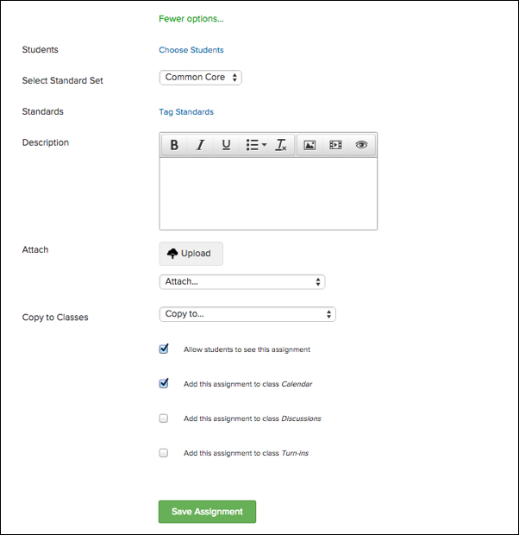
- Check or uncheck the additional settings at the bottom of the page:
  - Allow students to see this assignment allows students to view this assignment from their student accounts.
  - Add this assignment to class Calendar places the assignment on the class calendar.
  - Add this assignment to class Discussions allows students and parents to post discussion topics to a discussion board for this assignment.
  - Add this assignment to class Turn-ins allows students to turn-in assignments online from their student accounts.
- If you have already scored your students’ performance on the assignment, you can enter their scores under the Student Scores section. If enabled for your school, you can view any available custom codes under the Student Scores header. You may choose to enter a custom code as a student's score, rather than entering a point value.
Only your school administrator can add, modify, or delete the custom codes you can use in your class. Contact your school administrator to request any changes.
- If every student earned the same grade on the assignment, you can click the Copy to All link at the top right to copy the first student’s score to every student in the class.
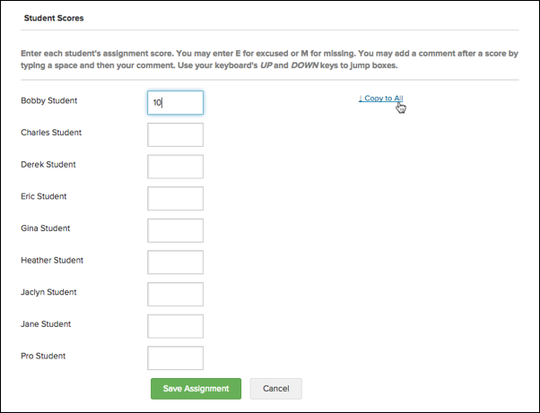
- Click the green Save Assignment button to create the assignment.

