Create Discussions
This topic covers how to create a discussion board in a class.
- Select a class to create a discussion for that class.
- Select Discussions from the left sidebar.
- To create a new discussion, click the New Discussion button.
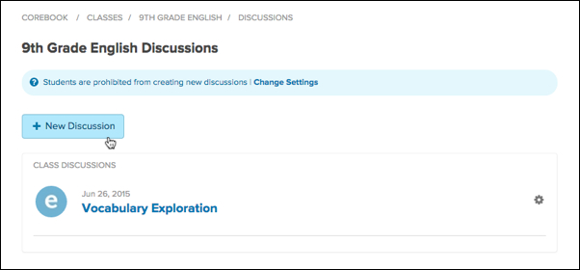
- In the pop-up window, give your discussion a Title, Date, Description, and attach files, if desired.
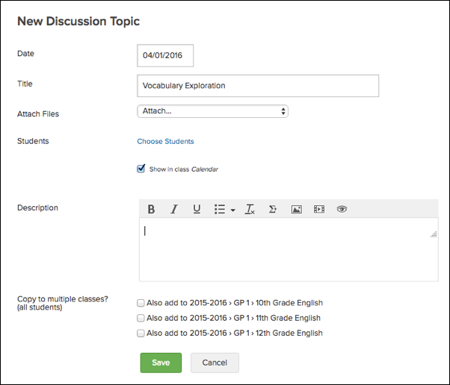
- If you wish to choose a select group of students to view the discussion topic, you may do so by selecting Choose Students. In the pop-up window, you will be able to select the students you wish to have access to the discussion.
- If you wish to add the discussion to the class calendar, you can check the box next to Show in class Calendar.
- You may also copy the discussion post to your other classes by checking the box next to each class that you wish to view the discussion.
- Click the green Save button to create your new discussion.

